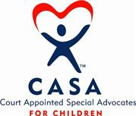 History of the CASA Movement

In 1977, a Seattle Superior Court Judge named David Soukup was concerned about trying to make decisions on behalf of abused and neglected children without enough information. He conceived the idea of appointing community volunteers to speak up for the best interest of these children in court. He made a request for volunteers; 50 citizens responded, and that was the start of the CASA movement.
Today, there are more than 59,000 advocates serving in 954 state and local program offices nationwide. CASA programs across the country are known by several different names, including Guardian ad Litem, Child Advocates and Voices for Children.
Since the inception of CASA advocacy, volunteers have helped more than 2 million children find safe, permanent homes in which they can thrive.

